Sprint 2

|  |  |
| --- | --- |
| Team ID | PNT2022TMID43478 |
| Project Name | Personal Assistance for Seniors Who Are SelfReliant |

1. Create a Form using Node-red to get the Medicine Details :

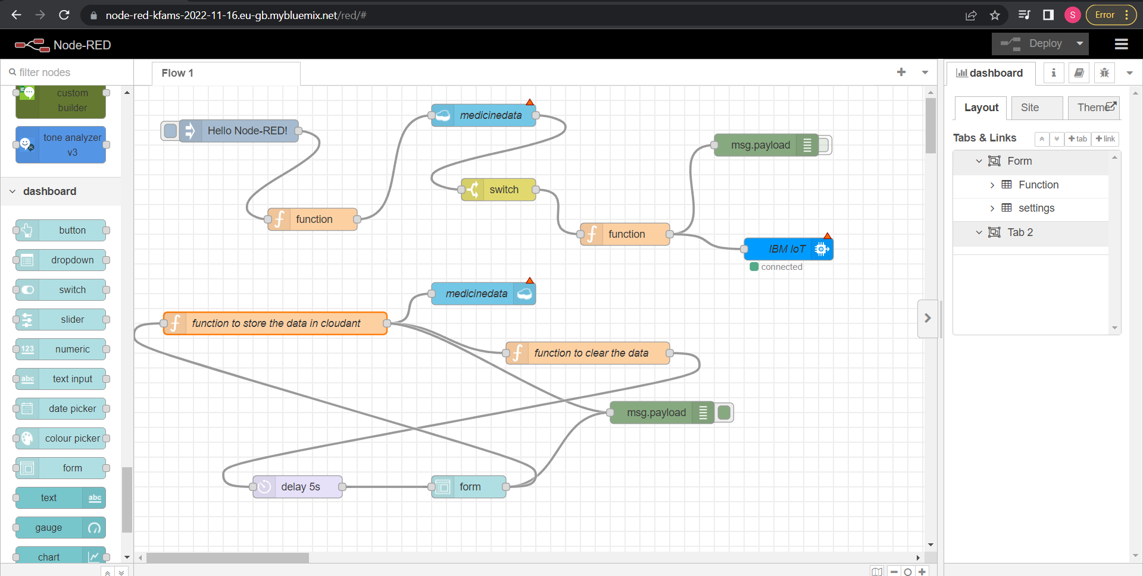

1. Adding IBM IoT Credentials to connect with virtual devices:

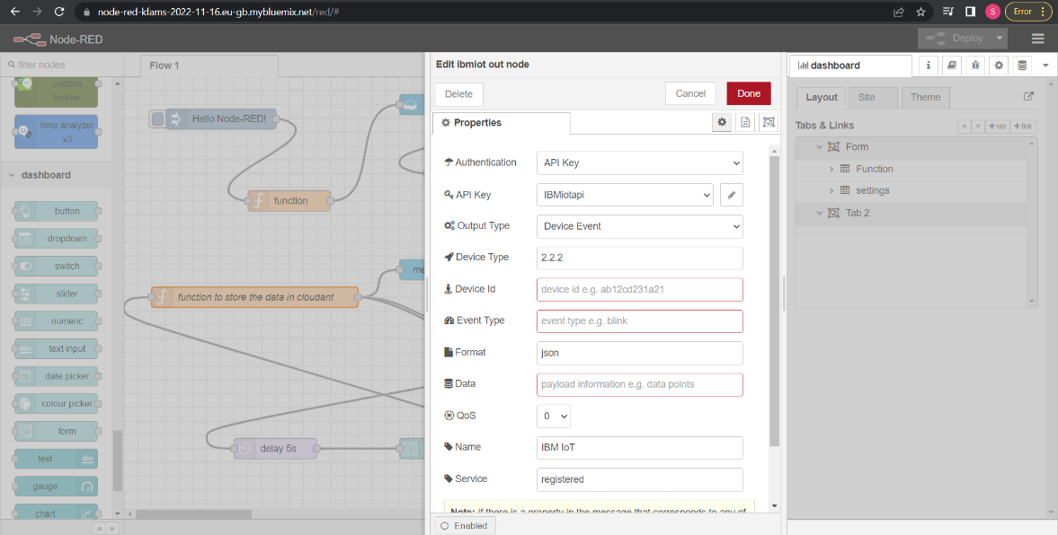

1. Function to Store the Medicine datas in Json format :

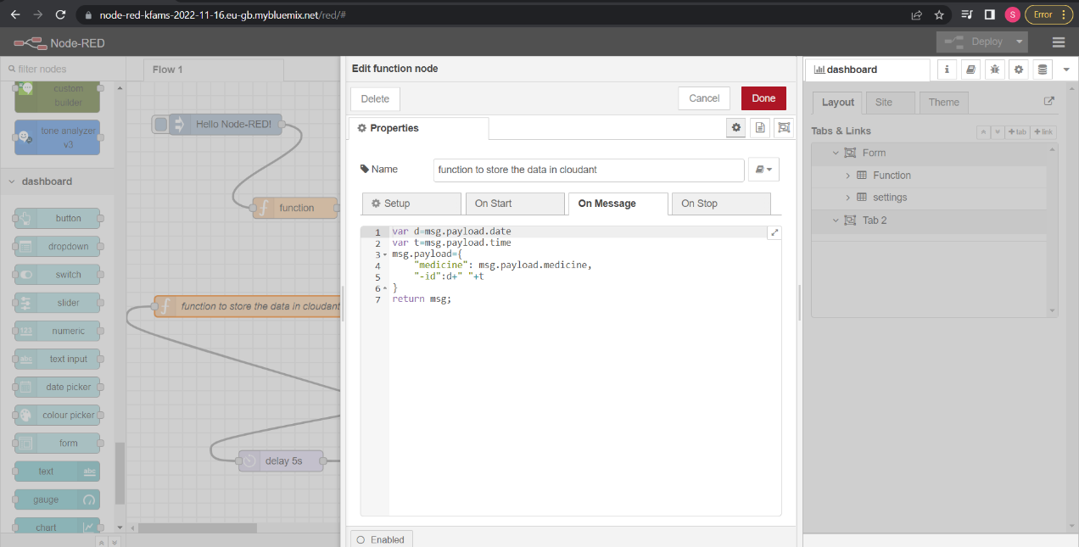

1. Compare the Present time with Stored time in cloudant :

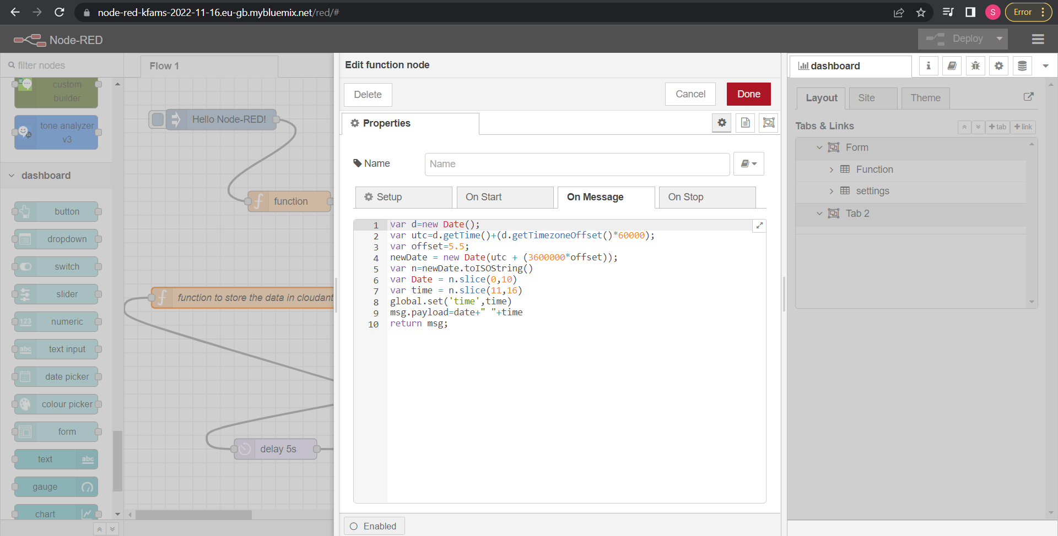

1. Form to Get the User Datas :

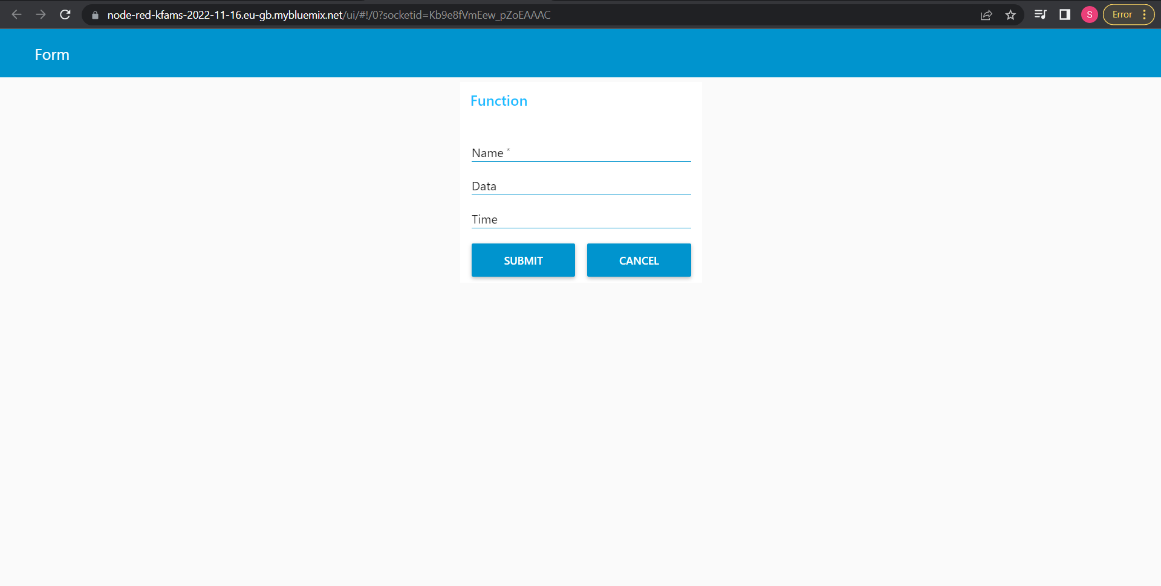

1. After getting the datas from form, store it in cloudant Database :

